The Standard of Ur
The Standard of Ur tells a story about a Sumerian battle fought in 2,600 B.C. The Standard of Ur is a wooden box with detailed designs. On each side of the box is a different picture that tells the story of the battle. It’s hard to understand what is happening on The Standard of Ur because the artists show the people standing there.
Below is the first side of the box. You’re supposed to read it from top to bottom. The bottom portion shows the battle.
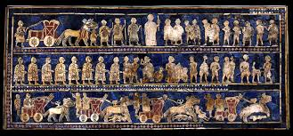
Below is the other side of the box. This side shows peace after the battle was fought. 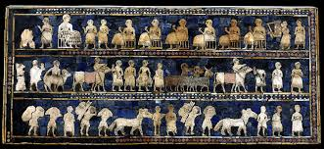

Akkadian Art
The Akkadian artwork is when action, or people moving starts to happen. Much of what we look at is carved in stone. The Akkadian Empire lasted only two centuries. Akkadians were the first people in Mesopotamia to show a lot of fighting. The Akkadians founded Babylon and were later called Babylonians.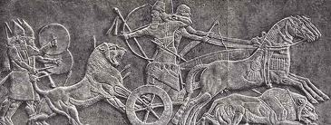

Babylon
An easy way to remember the artwork from Mesopotamia is to think of wars and battles as a large mess, like the word Mesopotamia. The Assyrians defeated the Akkadians. The Assyrians liked to fight, so they made “war” artwork.
In the Old Testament we are told of a huge tower (ziggurat). Unfortunately the ziggurat is no longer around, so we don’t know for sure if it was real. Below is a painting of what people thought the tower looked like.
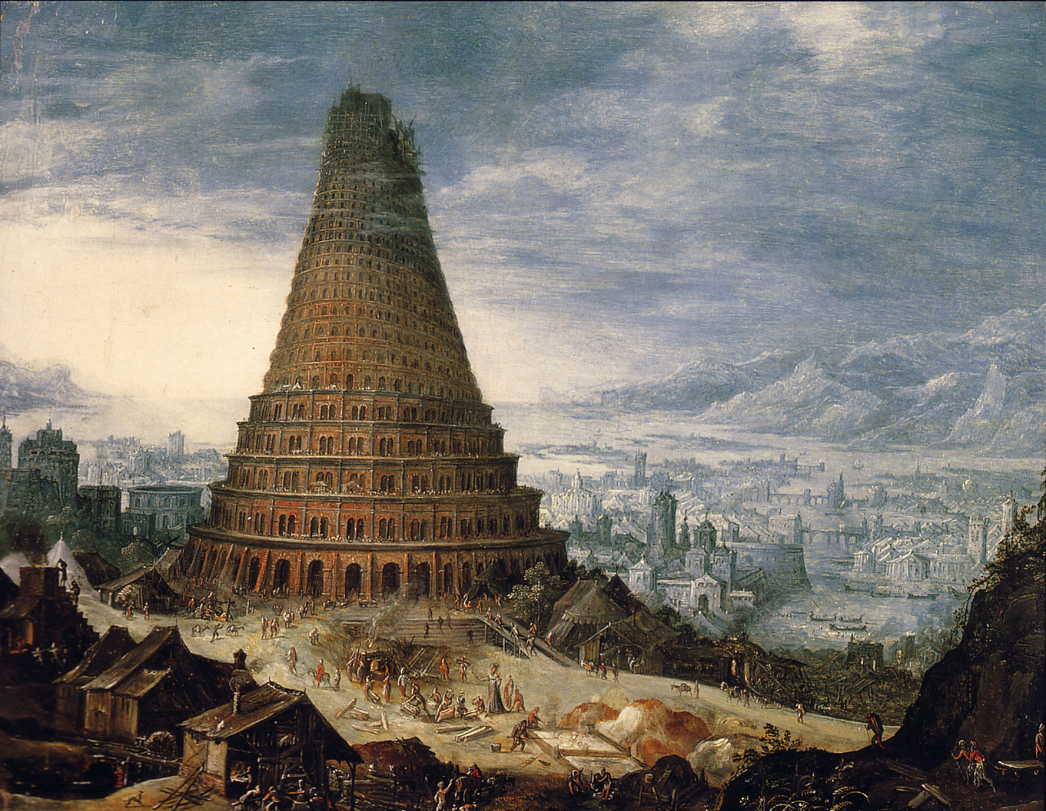
Also, there was another ziggurat built that had gardens on each level. It was called The Hanging Gardens of Babylon. The king of Babylon built the ziggurat for his wife. Shewas from a different part of the world with mountains. The king wanted the ziggurat to look like a mountain of plants and flowers.

New Babylon
The Persians attacked the capital of Babylon. The Persian General, Nabolassar became the first king of New Babylon. After the Persians took over war was not the purpose for art. The most important piece of art created during New Babylon was The Ishtar Gate. It was meant to show wealth, power and beauty. Below is the Ishtar Gate.
